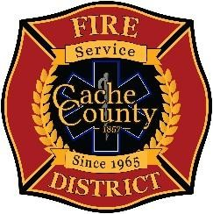
CACHE COUNTY FIRE DISTRICT
BOARD OF TRUSTEES
Kathryn Beus – Board Chair George Daines – Trustee
David Erickson – Trustee Kris Monson – Trustee
Lyndsay Peterson – Trustee Stephanie Miller – Trustee Larry Jacobsen - Trustee

BOARD OF TRUSTEES MEETING
October 30, 2025
2:00 pm
AGENDA

The Cache County Fire District Board will meet Tuesday, October 30, 2025, commencing at 2:00 p.m. in the Cache County Historic Courthouse, Council Conference Room, 199 North Main Logan, Utah 84321.

1. CALL TO ORDER

2. ITEMS OF BUSINESS
- Approval of Agenda – October 30, 2025
- Approval of Minutes – September 11, 2025

3. Welcome and Introduction of Trustee George Daines the new County Executive

4. ITEMS OF DISCUSSION
A. Report from Steering Committee

- DISCUSSION AND ACTION ON RESOLUTION 01-2025 – Approving and Authorizing the Execution of an
Interlocal Agreement for the Provision of Fire Services Between Cache County Fire Protection District and Cache County

- DISCUSSION AND ACTION ON RESOLUTION 02-2025 – Adopting Proposed Amendments to the District Bylaws which Amends the Selection Process of Members of the Board of Trustees

- NEXT MEETING – November 20, 2025 – 2:00pm

8. ADJOURN

In compliance with the Americans with Disabilities Act, individuals needing special accommodations (including auxiliary communicative aids and services) during this meeting should notify Janeen Allen, at 755-1850 at least three working days prior to the meeting.

